**Karan Arora**  **R.L. Institute M: 9416974837**

**Max Time : 2 hr** **Class = 12th Chemistry Test**  **Max Marks : 50**

**SOLUTION + ELECTROCHEMSITRY + BIOMOLECULES**

1. Multiple choice questions : [ 1 X 20 = 20]
2. Mole fraction of the solute in a 1 molal aqueous solution is :

|  |  |  |  |
| --- | --- | --- | --- |
| a) 0.1770 | b) 0.0177 | c) 0.0344 | d) 1.7700 |

1. An unripe mango placed in a concentrated salt solution to prepare pickle , shrivels because ________.

|  |  |
| --- | --- |
| a) it gains water due to osmosis | b) it loses water due to reverse osmosis |
| c) it gains water due to reverse osmosis | d) it loses water due to osmosis |

1. $Λ_{m ({NH}_{4}OH)}^{ο}$ is equal to :

|  |  |
| --- | --- |
| a) $Λ_{m ({NH}_{4}OH)}^{ο}$ + $Λ_{m ({NH}_{4}Cl)}^{ο}$– $Λ_{m (HCl)}^{ο}$ | b) $Λ_{m ({NH}_{4}Cl)}^{ο}$ + $Λ_{m (NaOH)}^{ο}$– $Λ_{m (NaCl)}^{ο}$ |
| c) $Λ_{m ({NH}_{4}Cl)}^{ο}$ + $Λ_{m \left(NaCl\right)}^{ο}$– $Λ_{m (NaOH)}^{ο}$ | d) $Λ_{m (NaOH)}^{ο}$ + $Λ_{m (NaCl)}^{ο}$– $Λ_{m ({NH}_{4}Cl)}^{ο}$ |

1. In comparison to a 0.01 M solution of glucose, the depression point of a 0.01 M MgCl2 solution is :

|  |  |  |  |
| --- | --- | --- | --- |
| a) the same | b) about twice | c) about 3 times | d) about 6 times |

1. Using the data given below find out the strongest reducing agent :

$E_{{Cr}_{2}O_{7}^{2-}/{Cr}^{3+}}^{o}$ = 1.33 V , $E_{{Cl}_{2}/{Cl}^{-}}^{o}$ = 1.36 V , $E_{{MnO}_{4}^{-}/{Mn}^{2+}}^{o}$ = 1.51 V , $E_{{Cr}^{3+}/Cr}^{o}$ = $-$ 0.74 V

|  |  |  |  |
| --- | --- | --- | --- |
| a) Cl – | b) Cr | c) Cr3+ | d) Mn2+ |

1. Which of the following naturally occurring $α$-aminoacids is optically inactive?

|  |  |  |  |
| --- | --- | --- | --- |
| a) Glycine | b) Alanine | c) leucine | d) valine |

1. Which one of following is always true about the spontaneous cell reaction in a galvanic cell?

|  |  |
| --- | --- |
| a) > 0 , Go < 0 , Q > Kc | b) < 0 , Go < 0 , Q < Kc |
| c) > 0 , Go > 0 , Q > Kc | d) > 0 , Go < 0 , Q < Kc |

1. The SI unit of conductivity is :

|  |  |  |  |
| --- | --- | --- | --- |
| a) S/m | b) S/cm | c) Sm | d) Scm |

1. Which of the following aqueous solutions should have the highest boiling point?

|  |  |  |  |
| --- | --- | --- | --- |
| a) 1 M NaOH | b) 1 M Na2SO4 | c) 1 M NH4NO3 | d) 1 M KNO3 |

1. The electrolyte used in the mercury cell is :

|  |  |
| --- | --- |
| a) paste of NH4Cl and ZnCl2 | b) Paste of HgO and carbon |
| c) paste of KOH and ZnO | d) paste of PbO and H2SO4 |

1. Which of the following pairs represents Anomers?

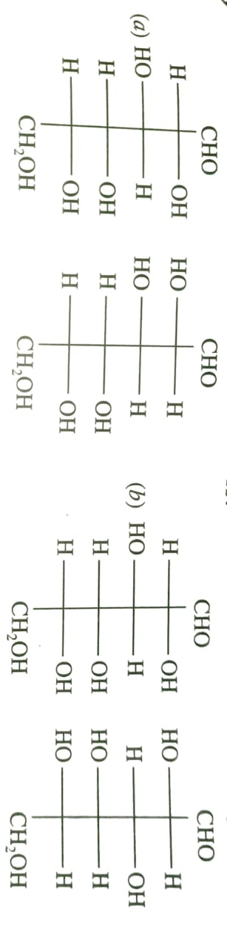

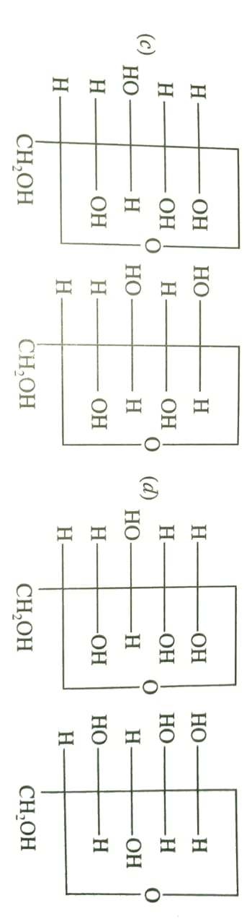

1. Cellulose is not digestible by human beings due to absence of cellulose hydrolyzing enzyme called :

|  |  |  |  |
| --- | --- | --- | --- |
| a) Cellulase | b) Invertase | c) zymase | d) urease |

1. Which of the following acids is a vitamin?

|  |  |  |  |
| --- | --- | --- | --- |
| a) Aspartic acid | b) ascorbic acid | c) adipic acid | d) saccharic acid |

1. DNA and RNA contain four bases each. Which of the following bases is not present in RNA?

|  |  |  |  |
| --- | --- | --- | --- |
| a) Adenine | b) uracil | c) Thymine | d) Cytosine |

1. **If both assertion and reason are true, but reason is the true explanation of the assertion.**
2. **If both assertion and reason are true, but reason is not the true explanation of the assertion.**
3. **If assertion is true, but reason is false.**
4. **If assertion is false, but reason is true.**
5. **Assertion:** Sucrose is a non-reducing sugar.

**Reason:** In sucrose, the aldehydic group of glucose and ketonic group of fructose are not free.

1. **Assertion:** Conductivity of all electrolytes decreases on dilution.

**Reason:** On dilution number of ions per unit volume decreases.

1. **Assertion:** All naturally occurring $α$-aminoacids except glycine are optically active.

**Reason:** Most naturally occurring amino acids have L-configuration

1. **Assertion:** The boiling point of pure solvent is always higher than the boiling point of solution.

**Reason:** The vapour pressure of the solvent decreases in the presence of non-volatile solute.

1. **Assertion:** Mercury cell does not give steady potential.

**Reason:** In the cell reaction, ions are not involved in solution.

1. **Assertion:** If more volatile liquid is added to another liquid, vapour pressure of solution will be greater than that of pure solvent.

**Reason:** Vapour pressure of solution is entirely due to solvent molecules

1. State Raoult’s law for the solution containing volatile components. Write two differences between an ideal solution and a non-ideal solution. [ 2 ]

**Or**

Write two difference between a solution showing positive deviation and a solution showing negative deviation from Raoult’s law.

1. What are three types of RNA molecules which perform different functions? [ 2 ]
2. Give reason : (a) Cooking is faster in pressure cooker than in cooking pan. [ 2 ]

(b) Red blood cell (RBC) shrink when placed in saline water but swell in distilled water.

1. At which pH of HCl solution will hydrogen gas electrode show electrode potential of – 0.118 V? H2 gas is passed at 298 K and 1 atm pressure. [ 2 ]
2. (a) Write the name of the cell which is generally used in hearing aids. Write the reaction taking place at the anode and the cathode of this cell. [ 3 ]

(b) Define secondary batteries

**Or**

One half-cell in a voltaic cell is constructed from a silver wire dipped in silver nitrate solution of unknown concentration. the other half-cells consists of a zinc electrode in a 0.1 M solution of Zn(NO3)2. A voltage of 1.48 V is measured for this cell. Use this information to calculate the concentration of silver ions in the solution. (Given : $E_{{Zn}^{2+}/Zn}^{o}$ = $-$ 0.763 V , $E_{{ Ag}^{+}/Ag}^{o}$ = 0.80 V)

1. Represent the cell in which the following reaction take place: [ 3 ]

2 Al (s) + 3 Ni2+ (0.1 M) 2 Al3+ (0.01 M) + 3 Ni (s). calculate the emf if Eo = 1.41 V.

1. (i) Define the following terms : Molarity and Molal elevation constant (Kb) [ 3 ]

(ii) A solution containing 15 g urea (molar mass = 60 g/mol) per litre of solution in water has the same osmotic pressure as a solution of glucose (molar mass = 180 g/mol) in water. Calculate the mass of glucose present in one litre of its solution.

1. Write the important structural and functional differences between DNA and RNA. [ 3 ]
2. Write the reactions involved when D-glucose is treated with following reagents: [ 5 ]

(i) HCN (ii) Br2 water (iii) NH2OH (iv) HNO3 (v) HI

1. (a) What are the Zwitter ion structure of glycine. [ 5 ]

(b) What is meant by reverse osmosis

(c) Write the recation occur during discharge of lead storage battery.